Right To Access Procedure.

Contents

Purpose 2

Scope 2

Review 2

Right To Access Procedure 3

The Procedure. 4

# Purpose

The purpose of the Right to Access procedure is to empower individuals with the ability to understand and control how their personal data is being used by an organization like Metropolis Transit. It is not just about providing individuals with a glimpse of their data, but also about improving an organization's overall data governance, which leads to improved data management and security policies.

# Scope

The procedure specified in this document applies to all information resources and assets that are owned by the company. And it’s applied to all staff, contractors, third parties, and to all other individuals or organizations who use, or support the use of the organization information processing environment. This procedure applies entirely in the organization.

# Review

The document shall be reviewed at least for each two months in case of major changes.

# Right To Access Procedure

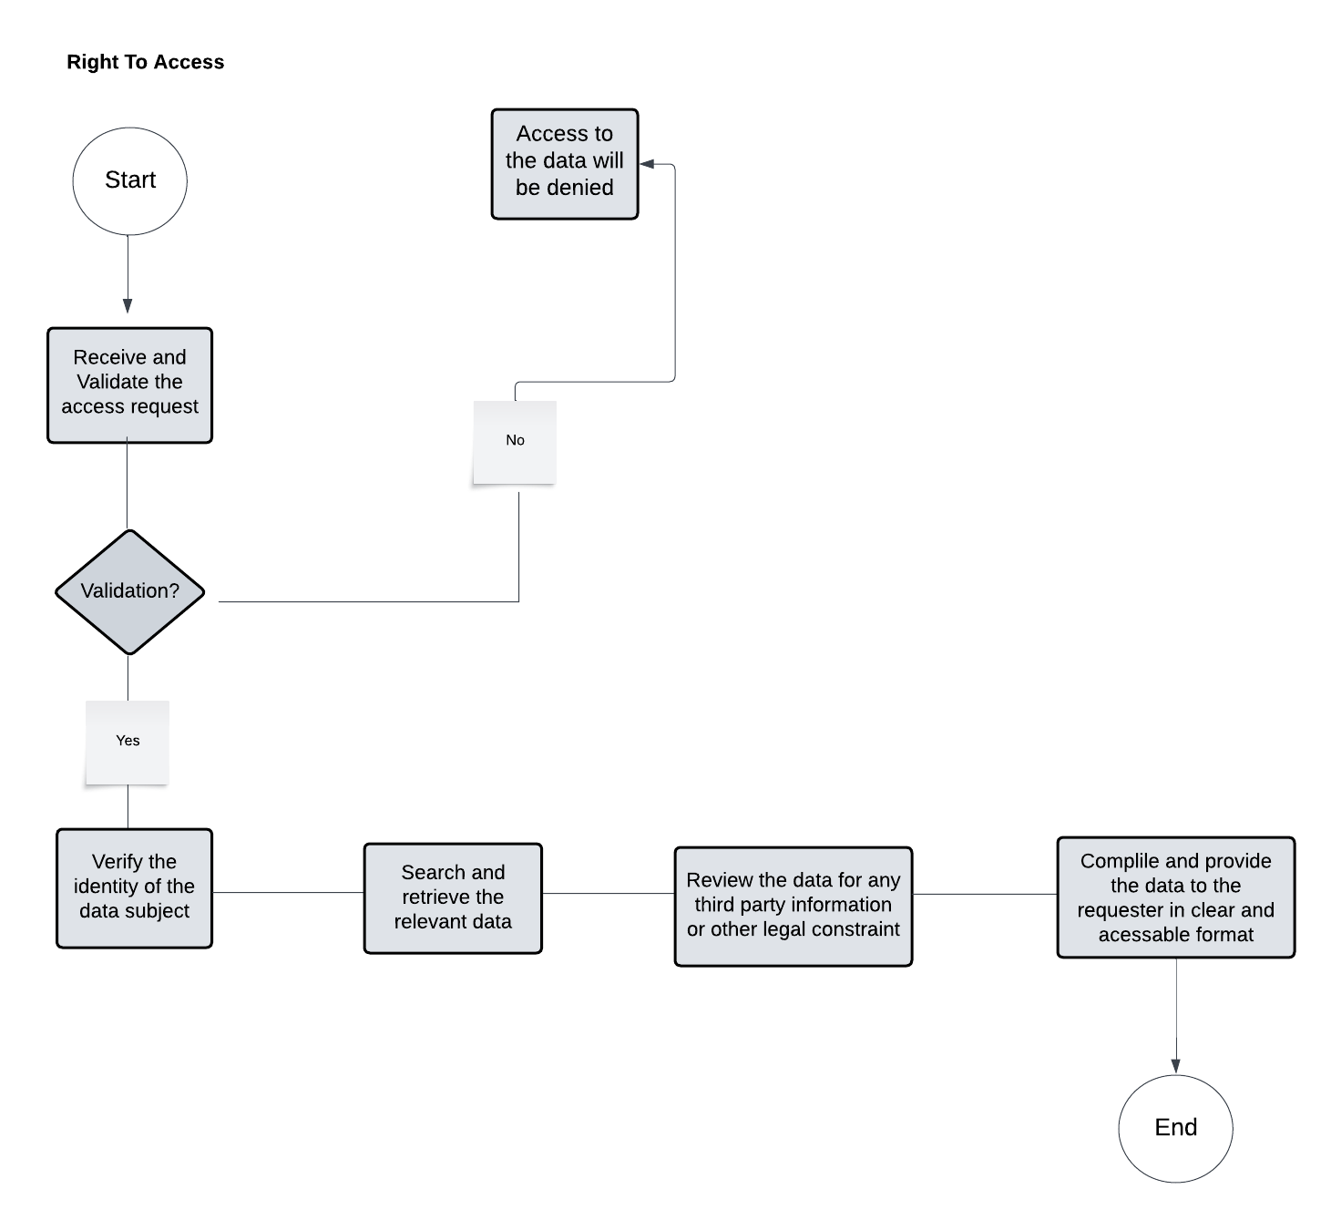

|  |  |  |
| --- | --- | --- |
| **The Activity ID** | **The Activity** | **Description on The Activity** |
| 1 | Receive and Validate the Access Request | Create a formal method for accepting requests (for example, a dedicated email address or an online form).  Ensure that the request includes all relevant information, such as the subject's identification and the precise data sought.  Check for completeness and legitimacy of the request. |
| 2 | Verify the Identity of the Data Subject | Implement identity verification mechanisms (for example, demanding ID and comparing personal information).  Ascertain that the person making the request is the data subject or a legally authorized representative. |
| 3 | Search and Retrieve the Relevant Data | Determine all systems and repositories where the subject's data might be kept.  To get the data, use efficient and accurate techniques (e.g., database queries, manual lookups). |
| 4 | Review the Data for Any Third-party Information or Other Legal Constraints | Examine the data for any information that might violate third-party rights or include sensitive information.  To comply with privacy regulations or agreements, information may be redacted or excluded. |
| 5 | Compile and Provide the Data to the Requester in a Clear and Accessible Format | Put the data together in a user-friendly format (e.g., PDF, structured data file).  Check that the data is complete and intelligible to the typical person. |

## The Procedure.